1914 Cadillac Inventory: (#’s refer to corresponding labels on each inventory box with car)

#1 Cylinder Head
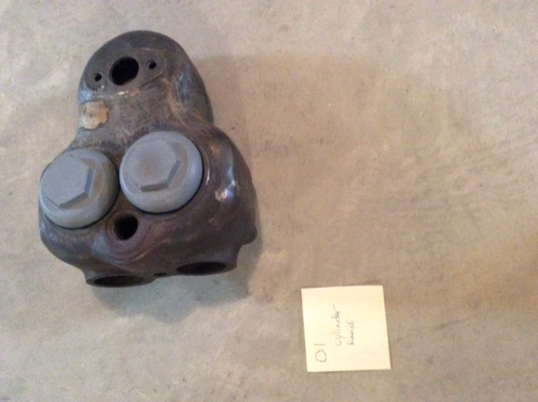

#2 Cylinder with water jacket

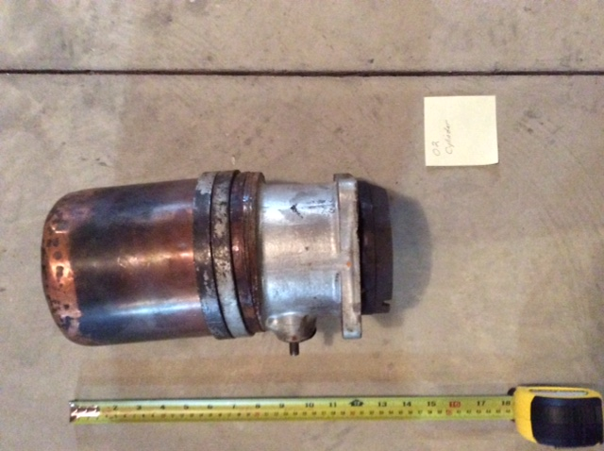

#3 Cylinder
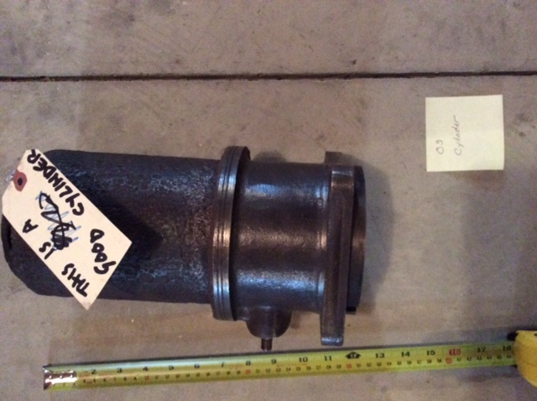

#4 Cylinder Head
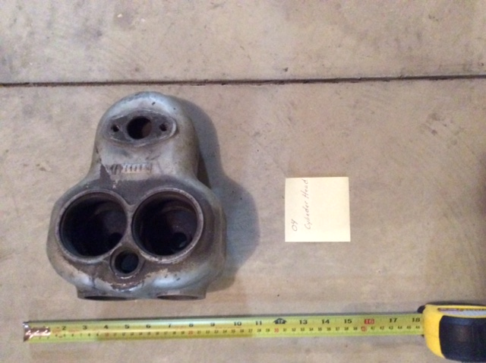

#5 Cylinder Head
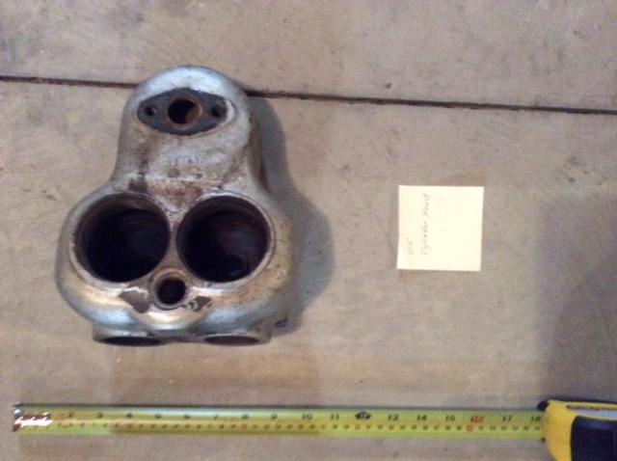

#6 Cylinder with water jacket
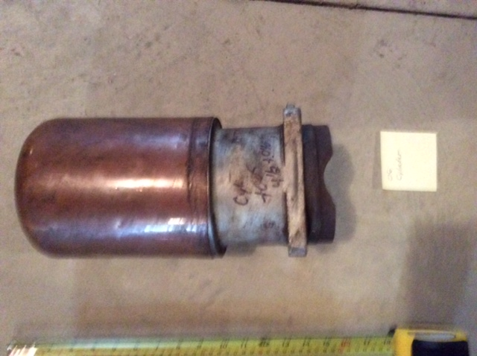

#7 Cylinder (labeled as cracked)

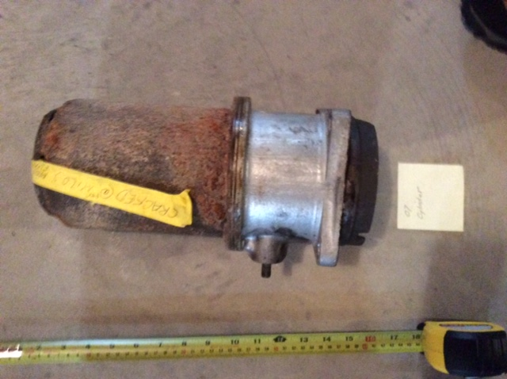

#8 Cylinder
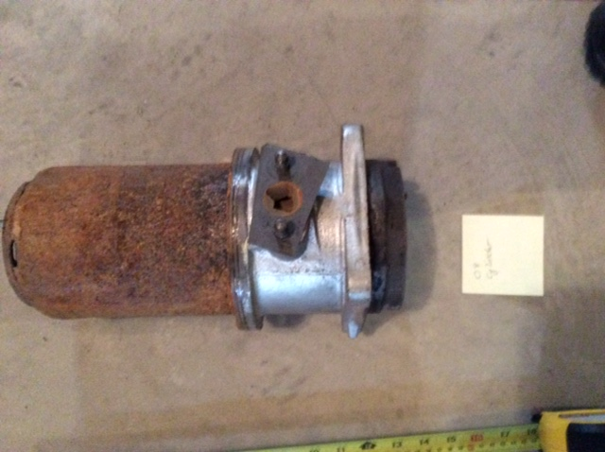

#9 Cylinder Head
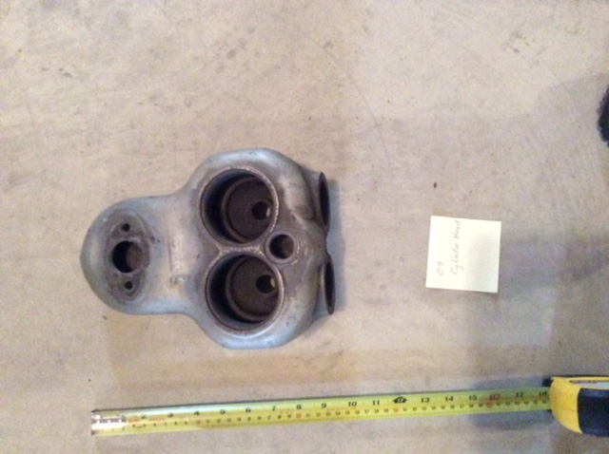

#10 Copper Water Jackets (4)
(2 of these may be newly remanufactured and unused)
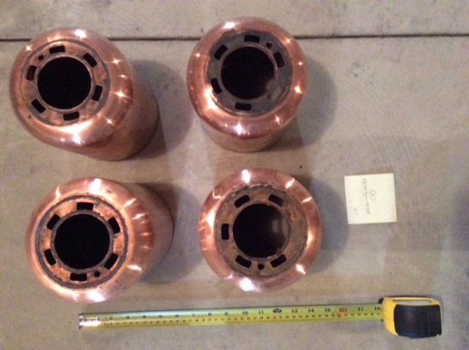

#11 Water Manifold

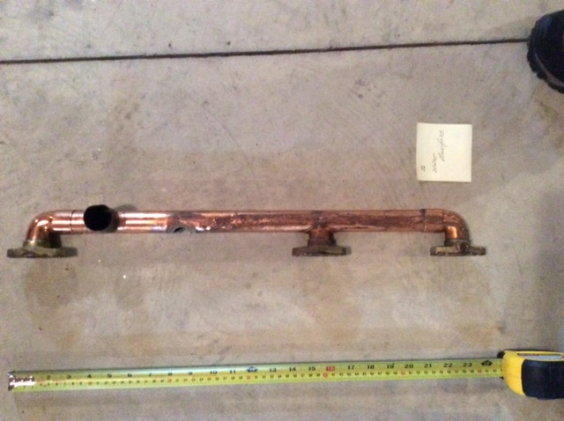

#12 Carburetor, Floats, and Float Needle Valve

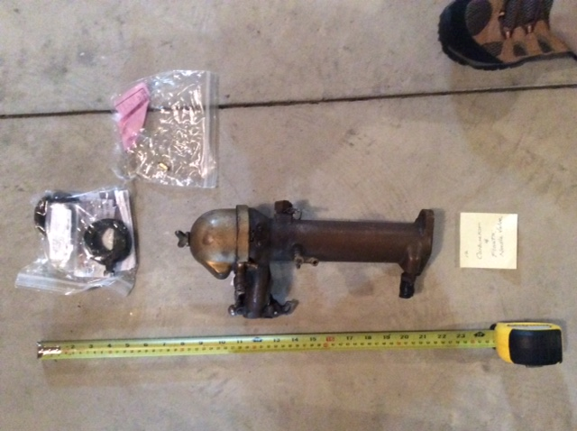

#13 Various Engine Parts, Including: Timing Chain(s), Lifter Covers (4), Main Bearings, etc.
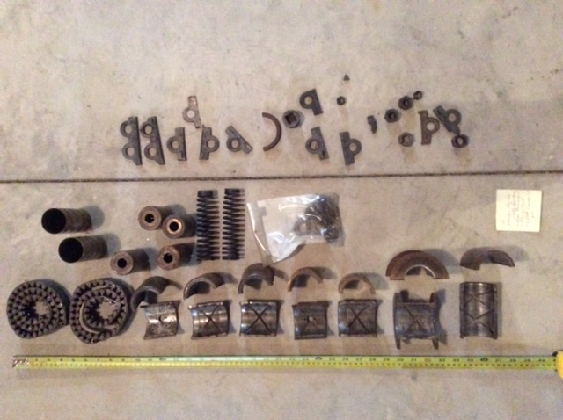

#14 Pulleys and Gears
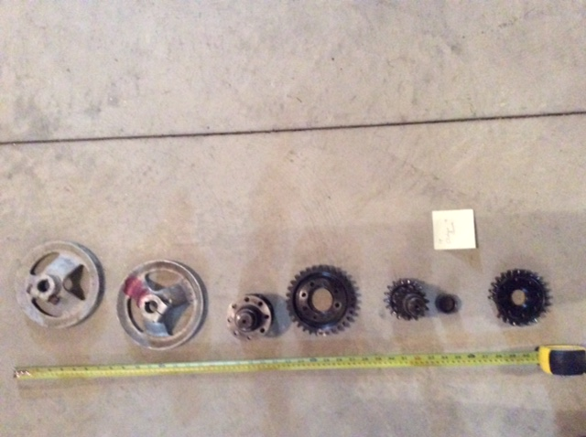

#15 Headlight Lenses & Other Lenses
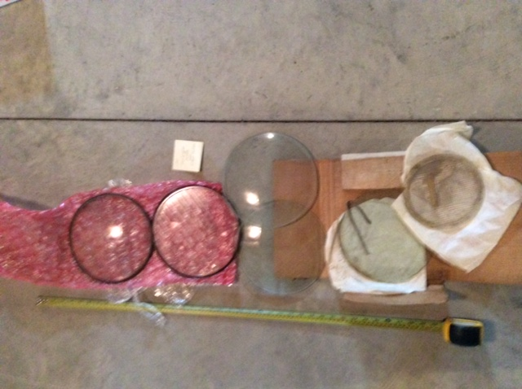

#16d Headlight Lenses (5)

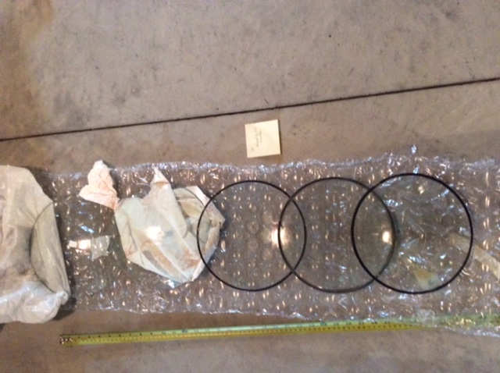

#17 Fan Blade and Pulley

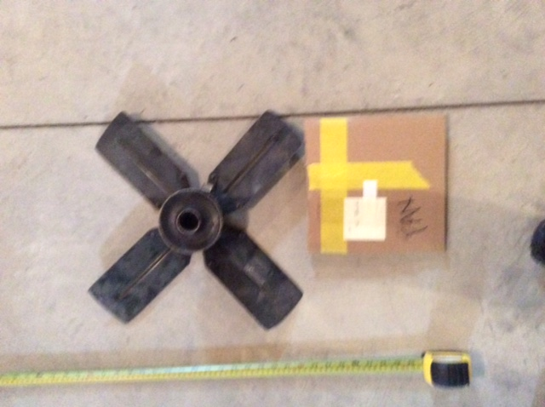

#18 “Fat Man” Steering Wheel

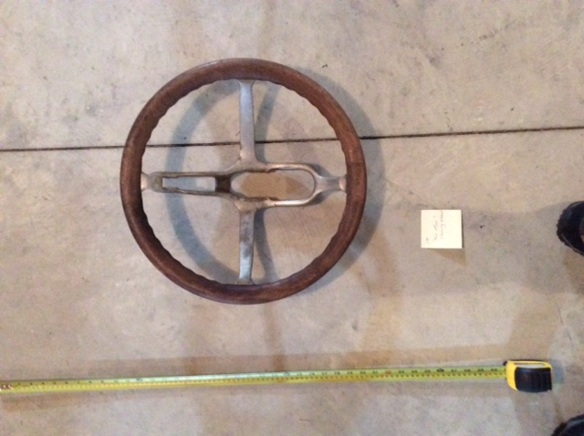

#19 Bearings, Gears, (?), etc.
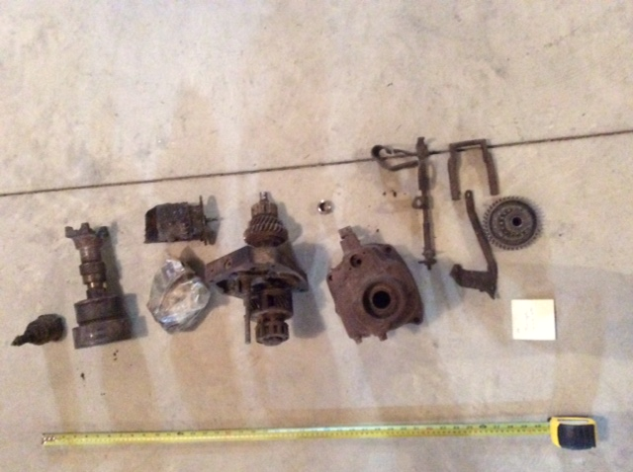

#20 Water Pump Blade(s), Nuts & Bolts, Springs, Cadillac Wrench, Ammeter, Grease Coupling, Hubcap,
Hood Latch, Air Hose, Valve Access Covers (8), Copper (?) O-Rings, Clutch Springs (?),
Valve Guide, Toolbox Supports, Countershaft Bearings, Headlight Bucket,
Horn (may fit better in its own box)
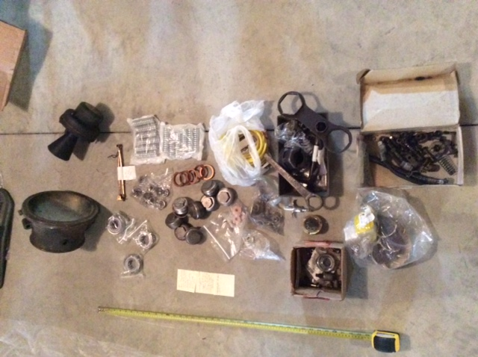

#21 Shroud
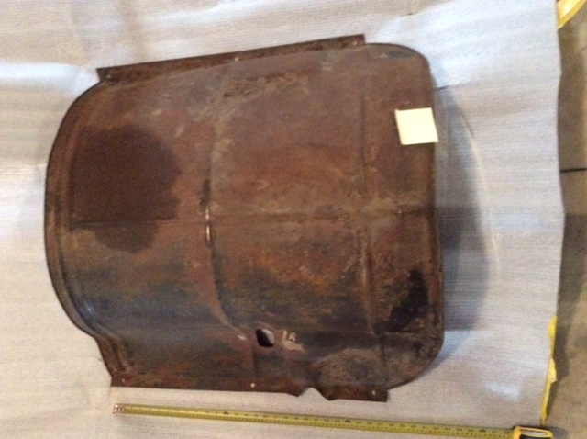

22. Tire Tool (?)
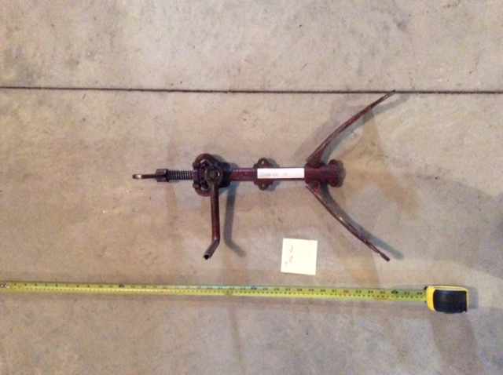

#23 Rear Axles - Pair
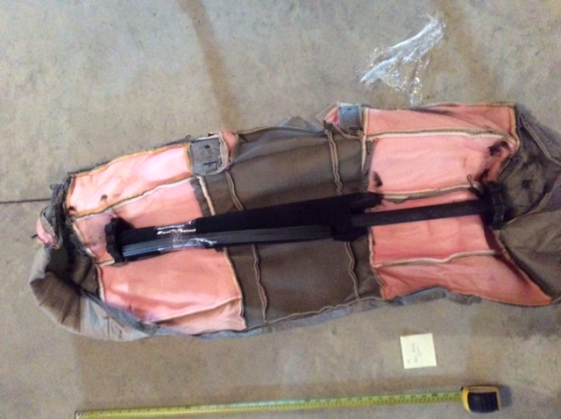

#24 Second Spare Tire plus Cover (6th tire with car, 2nd spare cover)
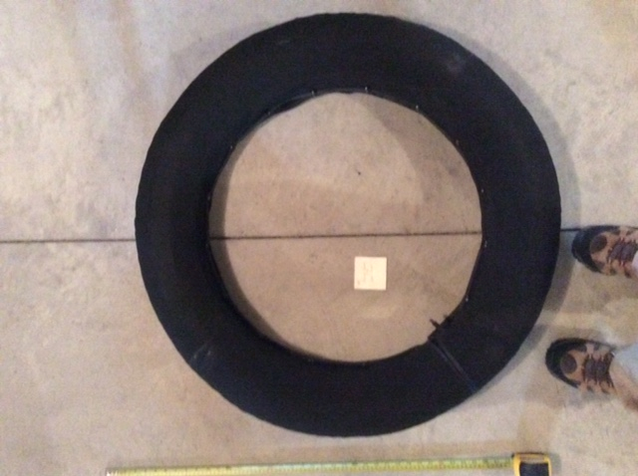

#25 Cowl Lights & Lenses (2 pr.), Headlight Rims (3), Headlight Buckets (3)
All “Gray & Davis”
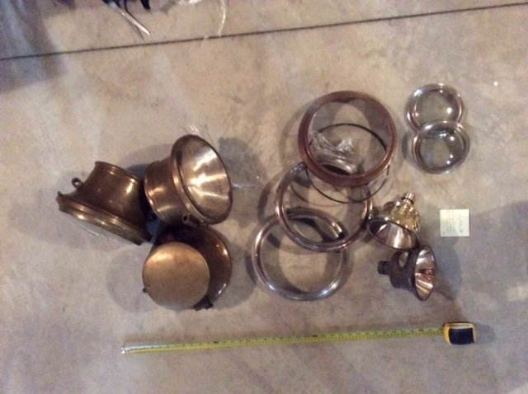

#26 Parts under Front Seat:
Cadillac: Tire Pressure Gage, Jack, Crank Handle, Wrenches, Coil, Oil Can, Air Hose with Gage, etc.

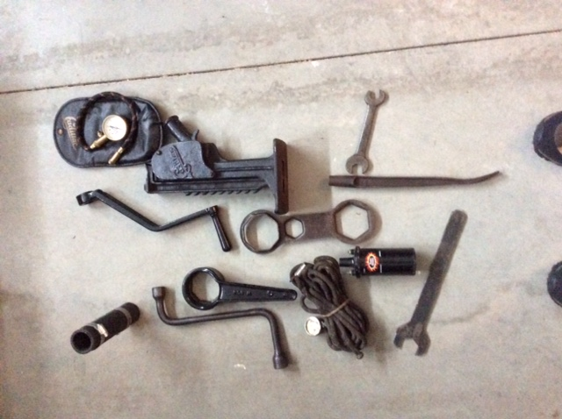

#27 Parts in “tool box” – forward portion:
Paint cans (body colors), Nuts & Bolts, Distributor, Original Coils (3), Wiring Diagram

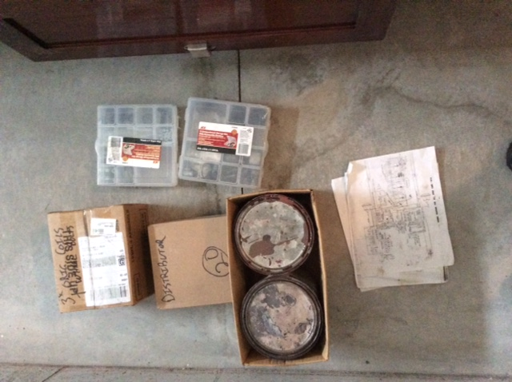

#28 Parts in “tool box” – rear portion:
Hubcaps, Ignition Parts, Coil Cover, Engine Parts,
Miscellaneous, including: Original Distributor, Delco Master Switch, Original Oil Can Mounting
for firewall, Piston Ring Sets

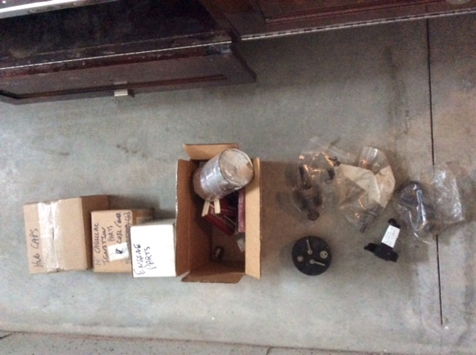

Inside front left door pocket: Parts List, Instruction Booklet (owner’s manual), extra keys, etc.
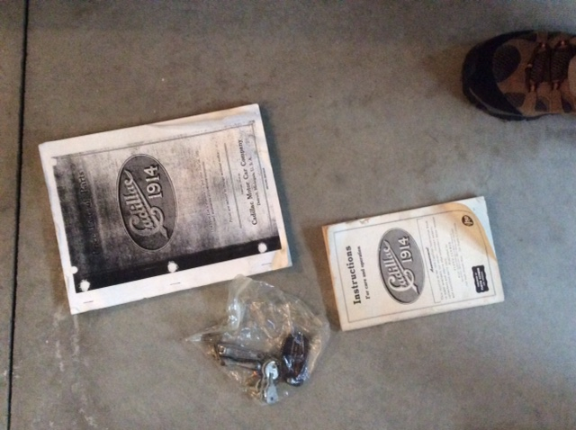

Not pictured:
Top (hood) boot
Tonneau covers (2); front left seat, front right seat
Side curtains (under rear seat)
Tool box cover
Flashlight at base of front seat
Fire extinguisher at base of front seat

